Executive Report
Youth Drug Use Analysis & Evidence-Based Policy Strategy
Research Context
The rising use of illicit drugs among youth is a pressing global concern. The survey targeted young individuals to explore age distribution, family environment, drug spending, initiation factors, help-seeking intentions, and prevention channel preferences. The objective is to provide evidence-based recommendations to guide government interventions and prevention strategies.
Key Findings
1. Demographics and Drug Use Patterns
Respondents had a mean age of 22.69 years (SD = 5.79), with a median age of 22 years, confirming that drug use initiation and regular consumption concentrates in early adulthood (Figure 9). Monthly expenditure on drugs averaged $175.55 (SD = $161.17, median = $140.50) (Figure 10). Spending patterns are positively skewed, indicating that while most users maintain relatively moderate expenditure levels (under $150/month), a smaller subset with potentially more severe dependencies reports substantially higher spending, with some individuals exceeding $500 monthly.
Implication: Interventions should target young adults in their early twenties, the critical age window for both initiation and escalation. The relatively young average age (22.69 years) highlights the urgency of prevention efforts targeting late adolescents (ages 16–20) before regular use patterns establish. High-spending users represent a distinct subgroup requiring intensive, specialized intervention beyond standard outreach programs, suggesting the need for tiered support services matched to consumption severity.
2. Family Environment
Respondents reported diverse family relationship experiences: very close and supportive (n=46), generally good (n=57), sometimes good/sometimes difficult (n=85), and often difficult or strained (n=12) (Figure 11). Notably, approximately half (51.5%) report supportive family environments, while 48.5% experience some degree of strain. One-way ANOVA reveals no significant effect of family relationship quality on monthly drug spending (F(3, 196) = 0.502, p = 0.681) (Figure 15), suggesting that consumption intensity among current users is independent of family dynamics.
Implication: While family support is protective for initiation, current consumption intensity is influenced more by individual attitudes and habits than family dynamics. Policy should incorporate family-based prevention programs for younger populations, but focus interventions on individual behavioural support for current users.
3. Reasons for Initiation
Top reasons for first drug use include easy availability (27), curiosity (26), family problems (23), escape problems (21), and peer pressure (21). Chi-square analysis reveals no association between initiation reason and current help-seeking (χ² = 10.44, p = 0.917).
Implication: Prevention programs must address multiple pathways simultaneously rather than targeting only one risk factor. Education and awareness should cover curiosity, peer influence, mental health support, and family challenges.
4. Help-Seeking Behaviour
A substantial proportion expressed interest in help: 77% (95% CI: 71.5–82.5%). Logistic regression shows importance of health is a significant predictor of help-seeking (OR = 1.615, p = 0.003), indicating that respondents who place high importance on health are approximately 61% more likely to seek help for each unit increase on the importance scale (Table 5). In contrast, monthly spending and family relationship quality were not significant predictors. ROC analysis demonstrates moderate predictive ability (AUC = 0.686).
Implication: Health-focused messaging is likely to resonate with young users. Intervention programs should emphasize wellbeing, health consequences, and lifestyle improvement, rather than focusing solely on moral or legal issues.
5. Preferred Prevention Delivery Channels
Respondents prefer school programs (64), community events (61), leaflets (59), parenting workshops (59), social media campaigns (57), TV/radio (57), and peer ambassadors (55). Chi-square tests indicate no significant association between drug access perception and help-seeking (χ² = 16.12, p = 0.096).
Implication: Multi-channel delivery is essential. Digital channels such as social media campaigns should be prioritized for reach and engagement, complemented by interactive workshops and community events.
Policy Recommendations
To address the growing issue of illicit drug use among young adults, five integrated policy strategies are proposed, grounded in the statistical findings of this analysis.
The first priority is health-focused messaging. Prevention and intervention campaigns should be framed around physical, mental, and social wellbeing rather than moral or legal concerns, reflecting the strong predictive link between health importance and help-seeking behaviour (OR = 1.615, p = 0.003, Table 5). Messaging such as “Your health, your future” and “Recovery is healthcare, not judgment” can reposition addiction as a treatable health condition. Collaboration with healthcare providers, fitness influencers, and wellness advocates will lend credibility. Social media campaigns, preferred by many respondents (n = 57), should feature authentic recovery stories from young adults. Success can be tracked through public awareness surveys assessing shifts in perception from moral failure to health condition.
The second strategy is multi-channel prevention with digital priority. Resources should be allocated proportionally to preference data: school programs (25%), community events (23%), and social media campaigns (22%), with the remainder across leaflets, parenting workshops, and peer ambassadors. School-based education should target ages 14–18—prior to typical initiation age (mean 22.7 years)—while peer ambassador networks of young adults aged 22–26 can authentically communicate with adolescents. Shareable mobile-optimised content such as short videos, infographics, and testimonials will ensure reach across digital platforms. Digital campaigns should launch within three months, with national rollout of school programs within one year.
Third, family-based early intervention is essential. Although family relationship quality does not significantly affect consumption intensity (ANOVA: F = 0.502, p = 0.681, Figure 15), family conflict is a common initiation trigger (n = 23, Figure 12). Parenting workshops and family counselling should therefore focus on early detection, effective communication, and emotional support for youth in strained households (48.5% of the sample). School counsellors and community workers must be trained to identify at-risk youth and connect families with services. The target is to reduce family-problem-related drug initiation by 30% within three years.
The fourth recommendation emphasises accessible, stigma-free support services. With approximately 77% of users expressing a desire for help (95% CI: 71.5–82.5%, ≈1,540 individuals in the population), policy should prioritise barrier removal. Establishing free, anonymous 24/7 helplines, online chat platforms, and walk-in counselling centres—along with treatment subsidies through universal healthcare—will normalise help-seeking. Public campaigns promoting “Help is free, confidential, and available now” can further reduce stigma. The goal is to reach 50–60% of help-seeking individuals (770–925 people) within two years.
Finally, a tiered intervention framework should align treatment intensity with addiction severity. Given the skewed spending distribution (mean $175.55, SD $161.17), low-intensity users (<$100/month) should receive brief counselling and online support, moderate users ($100–$300/month) should access structured outpatient programs and CBT, while high-intensity users (>$300/month) should enter residential or medication-assisted treatment with wraparound care. Initial screening will match individuals to appropriate services, with resource allocation balanced across prevention (40%), early intervention (35%), and intensive treatment (25%). This evidence-driven distribution maximises population health impact per dollar spent.
Conclusion:
The survey findings reveal a youth drug use crisis marked by early initiation (mean age 22.7 years), diverse entry pathways, and strong unmet demand for support services. The most actionable insight is the clear association between health consciousness and help-seeking behaviour (OR = 1.615, p = 0.003), indicating that public health framing—rather than criminalisation or moral messaging—offers the greatest potential for engagement.
Three critical insights should guide policy development. First, prevention must be multi-dimensional. With initiation drivers including easy access (n = 27), curiosity (n = 26), family problems (n = 23), and mental health challenges (n = 16), isolated interventions will achieve limited impact. Effective prevention requires concurrent attention to supply control, mental wellbeing, family support, peer influence, and social context.
Second, family dynamics affect initiation but not consumption intensity. Although 48.5% of users report strained relationships, ANOVA results (F = 0.502, p = 0.681) show no spending differences by family quality. Family programs are therefore most valuable for early prevention, while interventions for current users should focus on personal behavioural support and health messaging rather than family mediation.
Third, the large proportion seeking help (77%, 95% CI: 71.5–82.5%) presents both an opportunity and a policy imperative. Around 1,540 individuals in the target population are open to intervention but face barriers of cost, stigma, and access. Expanding free, anonymous, health-oriented services could deliver major public health gains.
Preferred outreach channels—school programs, community events, social media, and peer ambassadors—offer a clear roadmap for implementation. Digital-first engagement is crucial given the young median age (22 years), while maintaining traditional platforms such as TV, radio, and parenting workshops ensures full coverage.
Policy execution should follow a tiered framework: universal prevention for youth (40% of resources), targeted intervention for emerging users (35%), and intensive treatment for high-dependency cases (25%). With coordinated delivery across education, health, and community sectors, and continuous monitoring, governments can realistically aim for a 20–30% reduction in youth initiation and 50–60% engagement among help-seekers within 2–3 years—representing meaningful progress against a complex public health challenge.
Technical Appendix
B.1 Descriptive Analysis - Demographics and Spending
Purpose: To characterize the demographic profile and drug spending patterns of the surveyed population, establishing baseline understanding of the target population for policy intervention.
Respondent Age Distribution
The surveyed population exhibited a mean age of 22.69 years (SD = 5.79), with a median age of 22 years, indicating a predominance of younger adults in the sample (Figure 9).
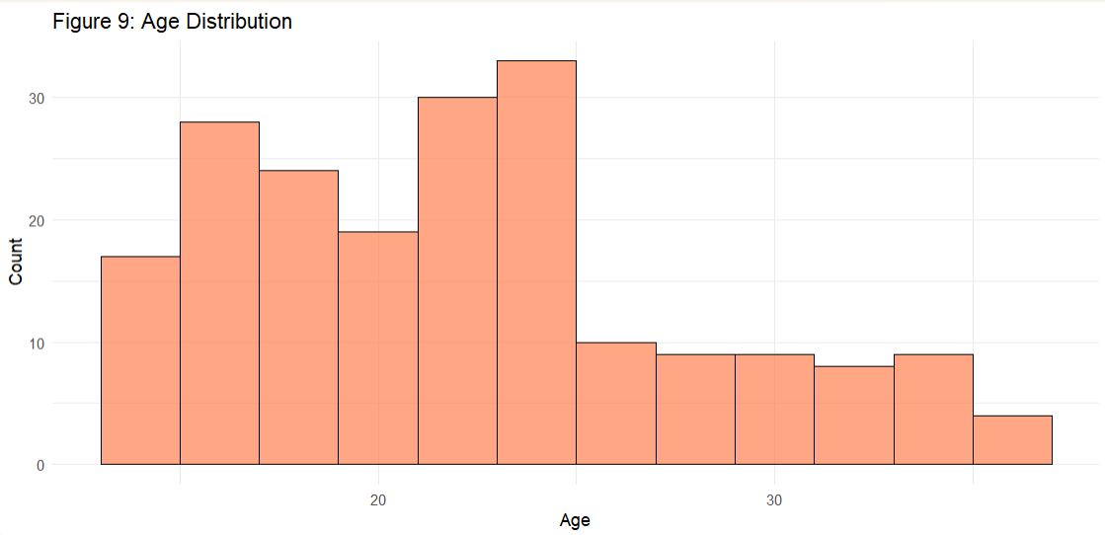
Figure 9: Age Distribution of Drug Users [Age histogram showing concentration in early-to-mid twenties]

Interpretation: The young average age confirms that drug use initiation and regular use concentrates in early adulthood, highlighting the critical importance of prevention efforts targeting adolescents and young adults.
Monthly Drug Expenditure
Monthly expenditure on drugs averaged $175.55 (SD = $161.17), with a median of $140.50, suggesting that while most respondents spend moderate amounts, a subset reports substantially higher spending (Figure 10).
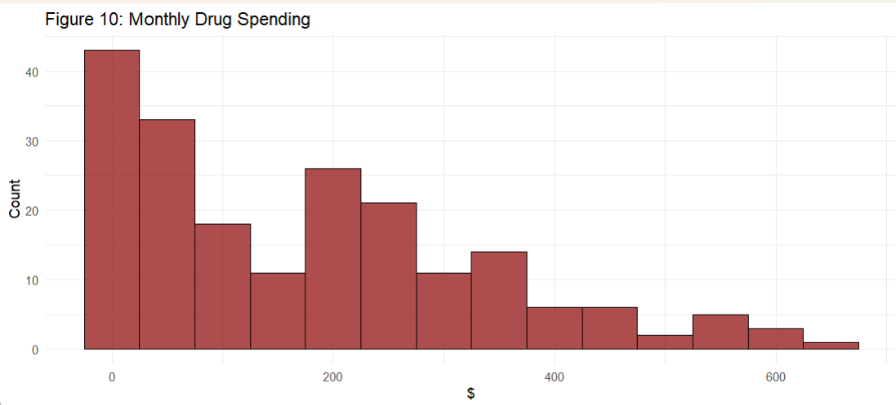
Figure 10:Distribution of Monthly Drug Spending [Spending histogram showing positive skew]

Interpretation: The positively skewed distribution indicates most users maintain relatively lower spending levels, while a smaller group with potentially more severe dependencies spend considerably more. This heterogeneity suggests the need for tiered intervention approaches.
B.2 Family Relationship Quality
Purpose: To understand the family environment context of drug users, informing family-focused prevention and intervention strategies.
Respondents reported varying family relationship experiences:
- Very close and supportive: 46
- Generally good: 57
- Sometimes good, sometimes difficult: 85
- Often difficult or strained: 12
These results highlight a mix of supportive and strained family environments, suggesting that prevention and intervention strategies should be tailored to accommodate both strong family networks and respondents with challenging family dynamics.
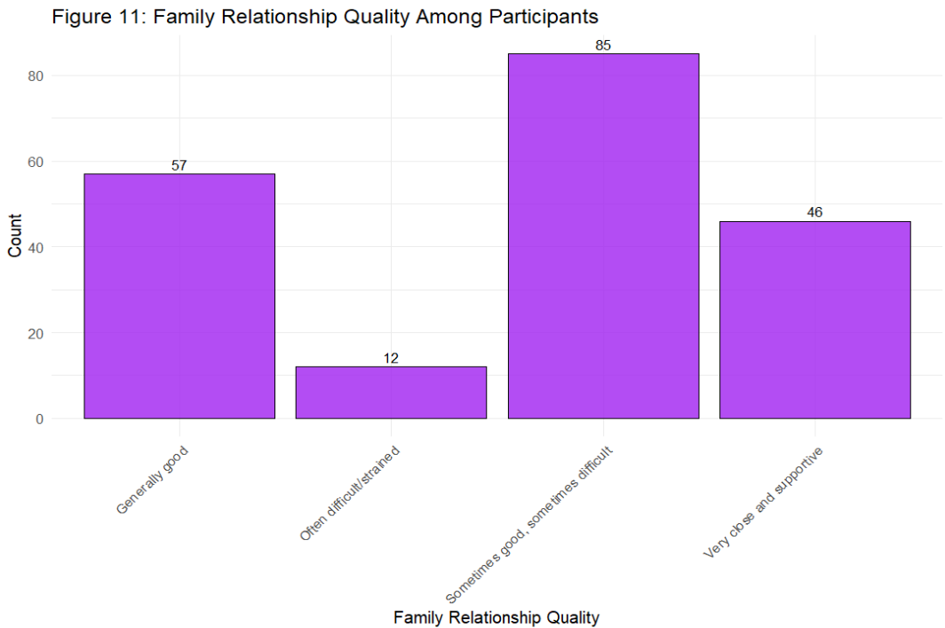
Figure 11: Distribution of Family Relationship Quality [Bar chart showing family relationship categories]
Interpretation: This distribution highlights a substantial proportion of respondents with supportive family environments (103 of 200, 51.5%: combining Very close and supportive and Generally good), alongside a meaningful fraction experiencing some strain (97 of 200, 48.5%: combining Sometimes good, sometimes difficult and Often difficult/strained). The diversity suggests that family dynamics play varying roles in individual drug use trajectories.B.3 Motivations for First Drug Use
Purpose: To identify primary drivers of drug initiation, informing targeted prevention messaging and early intervention strategies.
The primary self-reported reasons for first trying drugs were diverse. The top factors included:
- Easy availability: 27 respondents
- Curiosity: 26 respondents
- Family problems: 23 respondents
- Escape from personal problems: 21 respondents
- Peer pressure: 21 respondents
Additional factors such as boredom (19), academic pressure (18), stress relief (18), mental health challenges (16), and media glamorization (11) also contributed to first use, reflecting a complex interplay of social, psychological, and environmental drivers (Figure 12).

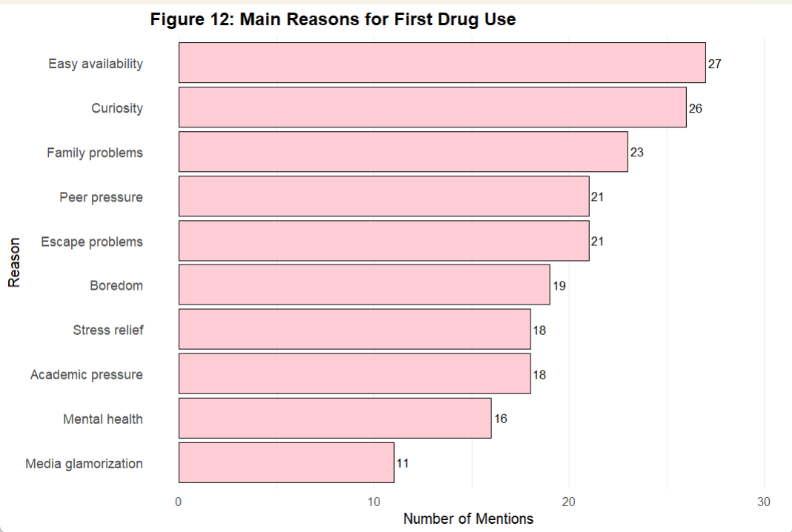
Figure 12: Reasons for First Drug Use [Bar chart showing diverse initiation factors]
Interpretation: The diversity of initiation pathways indicates that single-factor prevention campaigns will have limited effectiveness. Successful prevention requires multidimensional approaches addressing psychological wellbeing, family dynamics, social pressures, and environmental factors simultaneously.B.4 Desire for Support - Population Proportion Estimate
Purpose: To estimate the proportion of drug users wanting help and establish confidence intervals, quantifying the potential demand for intervention services.
A substantial majority of respondents (77.0%, n = 154/200) indicated that they would like to receive help regarding their drug use. Applying a finite population correction to account for the larger population size (N = 2,000), the 95% confidence interval for this proportion was estimated at [71.5%, 82.5%].

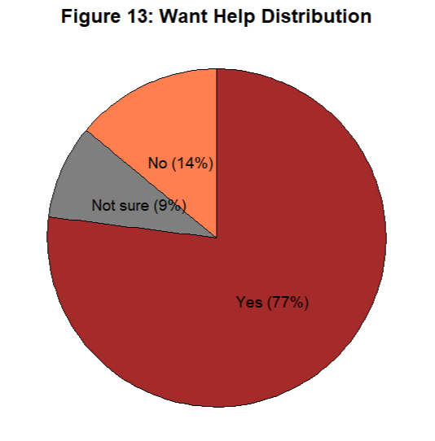
Figure 13: Desire for Help to Stop Drug Use [Pie chart showing 77% wanting help]
Interpretation: This finding suggests a strong demand for intervention programs and support services among the surveyed population. Approximately 1,540 individuals (77% of 2,000) in the target population would be receptive to help, representing a significant opportunity for targeted intervention programs.
B.5 Chi-Square: Drug Accessibility vs Desire for Help
Purpose: To examine whether perceived ease of drug access influences willingness to seek help, informing whether accessibility reduction strategies would increase help-seeking behaviour.
A chi-square test of independence was conducted to examine the relationship between respondents' perceived drug accessibility (rated on a scale) and their desire to seek help.
Chi-Square Results: χ²(10, N = 200) = 16.124, p = 0.096
Interpretation: The test results indicate no statistically significant association between drug accessibility and willingness to seek help (p > 0.05). This suggests that, within this sample, the ease of access to drugs does not meaningfully influence respondents' expressed interest in receiving support.
Policy Implication: While supply reduction remains important for primary prevention, accessibility levels do not appear to affect help-seeking among current users. Intervention strategies should focus on reducing barriers to treatment access rather than assuming that reduced drug availability alone will increase help-seeking.
B.6 Logistic Regression: Predictors of Help-Seeking Behaviour
Purpose: To identify which factors significantly predict desire for help, enabling targeted intervention strategies focusing on individuals most likely to engage with services.
A logistic regression model was fitted to predict the likelihood of respondents wanting help (Yes/No) using three predictors: monthly drug spending, perceived importance of health (1–5 scale), and family relationship quality (numerically coded, with lower values indicating closer relationships).
Model Results:
Predictor | Odds Ratio (OR) | 95% CI | p-value
Monthly Drug Spend | 1.002 | [1.000,1.004] | 0.071
Importance of Health | 1.615 | [1.178,2.214] | 0.003
Family Relationship Quality | 1.35 | [0.909,2.005] | 0.127

Table 5: Logistic Regression Predicting Desire for Help
Interpretation:
- Monthly drug spend had a positive but marginally non-significant association with wanting help (OR = 1.002, p = 0.071), suggesting that higher spending slightly increases the probability of seeking support, though not conclusively.
- Importance of health was a significant positive predictor (OR = 1.615, p = 0.003), indicating that respondents who place higher importance on health are about 61% more likely to express a desire for help for each unit increase on the importance scale.
- Family relationship quality was not a significant predictor (OR = 1.35, p = 0.127), suggesting that family closeness or strain does not strongly influence help-seeking behavior in this sample.
Policy Implication: Intervention campaigns should emphasize health consequences and frame addiction support as a healthcare issue rather than moral or criminal. Health-conscious messaging is most likely to engage individuals ready to seek help.
Purpose: To identify the most effective channels for reaching the target population with prevention and intervention messaging.
Respondents reported their preferred methods for drug prevention delivery, with multiple selections allowed. The top methods were:
- School programs: 64 mentions
- Community events: 61 mentions
- Leaflets: 59 mentions
- Parenting workshops: 59 mentions
- Social media campaigns: 57 mentions
- TV/radio campaigns: 57 mentions
- Peer ambassadors: 55 mentions

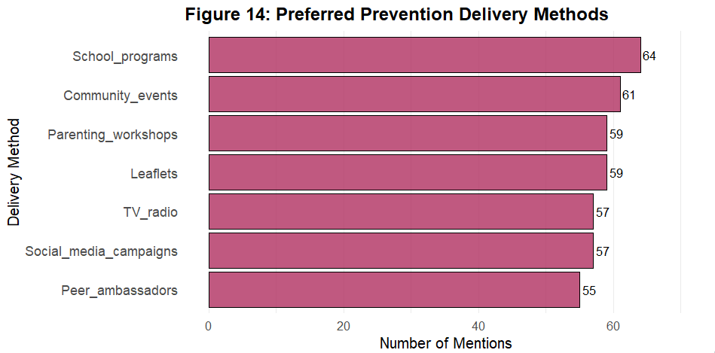
Figure 14: Preferred Prevention Delivery Methods [Bar chart showing preference rankings]
Interpretation: This suggests that interactive and accessible approaches, such as school programs, community events, and social media, are the most favored channels for prevention interventions. Digital-native communication strategies should be prioritized, while maintaining traditional channels to ensure comprehensive reach across diverse populations.
Purpose: To examine whether family environment quality is associated with the intensity of drug use, as measured by monthly spending, informing family-strengthening intervention priorities.
A one-way ANOVA was conducted to examine whether monthly drug spending differed across levels of family relationship quality (four categories).
ANOVA Results: F(3, 196) = 0.502, p = 0.681
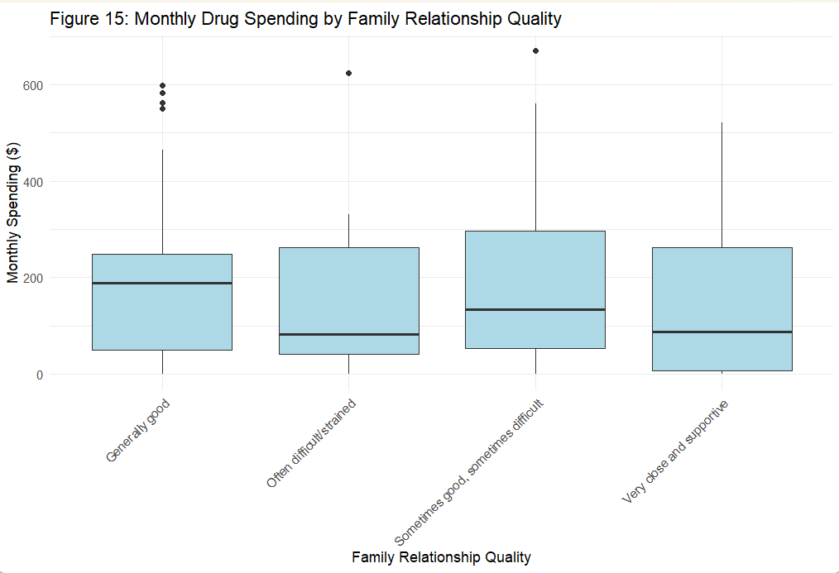
Figure 15: Monthly Drug Spending by Family Relationship Quality [Boxplot showing spending across family relationship categories]
Interpretation: The analysis found no statistically significant differences in spending between groups (p = 0.681). This suggests that, in this sample, the perceived quality of family relationships does not meaningfully impact the amount respondents spend on drugs.
Policy Implication: While family relationships may influence drug initiation (as seen previously), they do not appear to affect usage intensity once regular use is established. Family-strengthening programs are therefore most effective as primary prevention measures, rather than as interventions for reducing consumption among current users.
B.9 Chi-Square: Reason for First Use vs Desire for Help
Purpose: To determine whether initial motivations for drug use predict current willingness to seek help, informing whether prevention messaging should be tailored to different initiation pathways.
A chi-square test of independence was conducted to examine the relationship between respondents' main reason for trying drugs for the first time and their current desire for help.
Chi-Square Results: χ²(18) = 10.439, p = 0.917
Interpretation: The test indicated no significant association (p = 0.917), suggesting that the initial motivation for drug experimentation does not influence whether individuals currently want support or intervention.
Policy Implication: Preventive strategies should not assume that early reasons for drug use predict willingness to seek help. Intervention approaches should be universal and accessible regardless of initiation pathway, focusing instead on current readiness factors such as health consciousness.
B.10 ROC Analysis: Logistic Regression Model Performance
Purpose: To evaluate the predictive accuracy of the logistic regression model in classifying individuals who want help versus those who do not.
The logistic regression model predicting respondents' desire for help was evaluated using a Receiver Operating Characteristic (ROC) curve.
ROC Results: Area under the curve (AUC) = 0.686
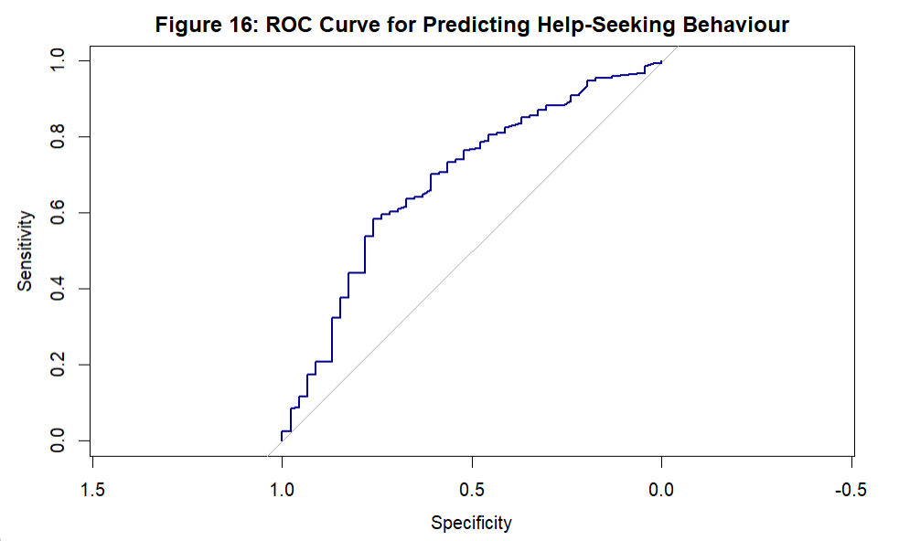
Figure 16: ROC Curve for Help-Seeking Prediction Model
Interpretation: An AUC of 0.686 indicates moderate discriminative ability. The ROC curve shows that the model distinguishes respondents who want help from those who do not better than chance (AUC = 0.5), but it is not highly predictive (AUC < 0.7). This suggests that additional predictors or more detailed behavioral measures may be necessary to improve classification performance.
Research Implication: Future studies should explore additional psychological, social, and behavioral variables that may better predict help-seeking readiness among drug users.
B.11 Conclusion - Drug Use Survey Analysis
The analysis of the drug use survey provides a detailed understanding of users’ demographics, behaviors, and help-seeking intentions. Respondents were relatively young, with a mean age of 22.7 years (SD = 5.79) and a median of 22 years, and exhibited varied monthly spending on drugs, averaging $175.55 (SD = 161.17) with a median of 140.5, indicating a positively skewed distribution. A substantial majority of respondents (77.0%, 95% CI: 71.5–82.5%) expressed a desire for help, underscoring a strong opportunity for intervention programs.
Family relationship quality did not significantly influence monthly spending (ANOVA: F(3,196) = 0.502, p = 0.681) or the likelihood of seeking help, although descriptive patterns suggest that supportive family environments may be linked to slightly lower drug expenditures. Logistic regression results indicated that perceived importance of health was a significant positive predictor of help-seeking (OR = 1.615, p = 0.003), whereas monthly spending and family relationship index were not significant predictors. The model showed moderate discriminative ability (ROC AUC = 0.686), suggesting that additional behavioral or psychological factors could improve predictive accuracy.
Chi-square analyses revealed no significant associations between drug accessibility or initial reasons for trying drugs and current help-seeking behavior (p = 0.096 and p = 0.917, respectively), indicating that desire for help is driven more by personal attitudes toward health than by access or early experimentation. Preferences for prevention delivery methods were diverse, with school programs, community events, leaflets, parenting workshops, and social media campaigns being most frequently selected, highlighting the importance of using multiple communication channels for effective outreach.
Overall, these findings suggest that interventions targeting health awareness and delivered through preferred and accessible channels are likely to be most effective in encouraging help-seeking among young drug users. Prevention strategies should address multiple pathways of initiation simultaneously, and intervention programs should be framed as healthcare support services to maximize engagement among health-conscious individuals.

